**A. P. C. Mahalaxmi college for women, Tuticorin**

Department of mathematics (UA)

**Project Report Template**

**Project Title:**

I Revolution: A Data-driven exploration on apple iPhone impact in India.

**Team members:**

* V. Ishwarya
* A. Remonicka
* P. Abinaya
* G. Nanthini

**1 Introduction:**

1.1: Overview

* My project is about apple iPhone impact in India.
* This is one of the best topic we have worked on.
* We gained a lot of knowledge about apple iPhone’s features and specification.

1.2: Purpose

* It is a new experience for us.
* Apple has pioneered innovations in the

recycling and sourcing of materials to spur industrywide change.

* Bringing the best user experience to customers through innovative hardware, software and services.

**2 Problem definition & design thinking**

2.1 Empathy map

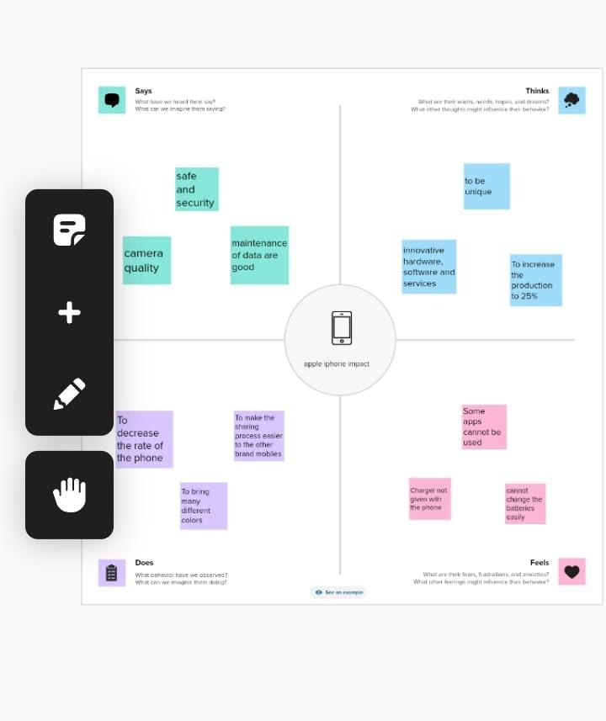

2.2 Ideation and brainstorming map

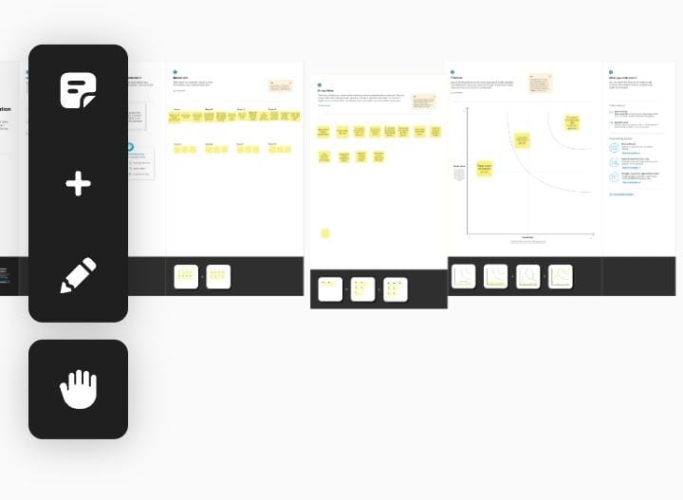

**3 Result**



++++++++++++++++++++++++++++++++++++++++++++++++++++++++++++++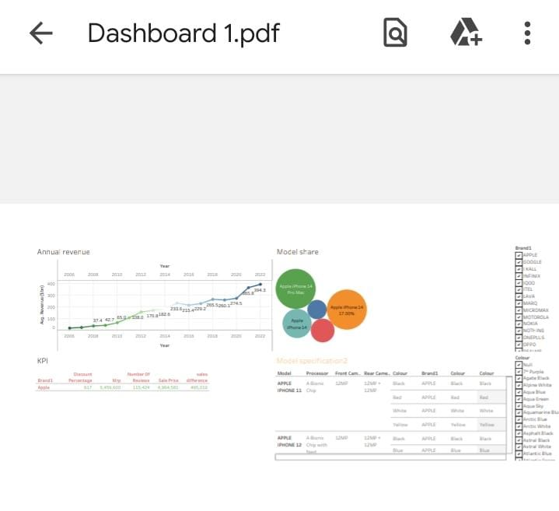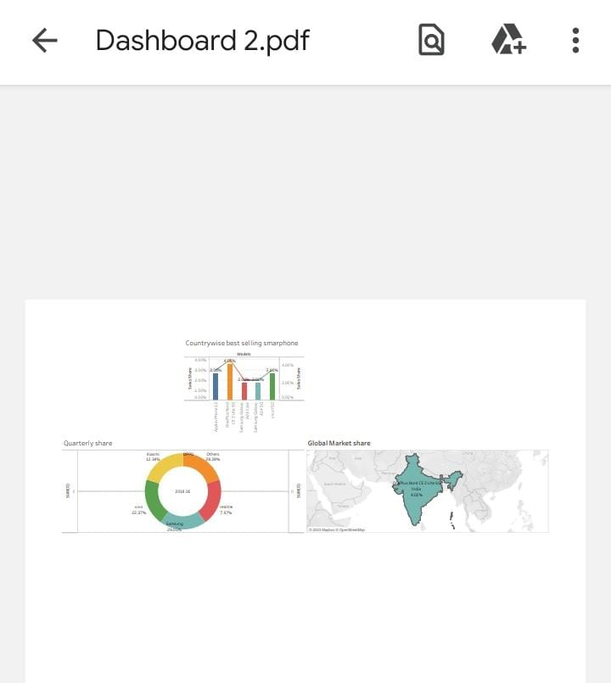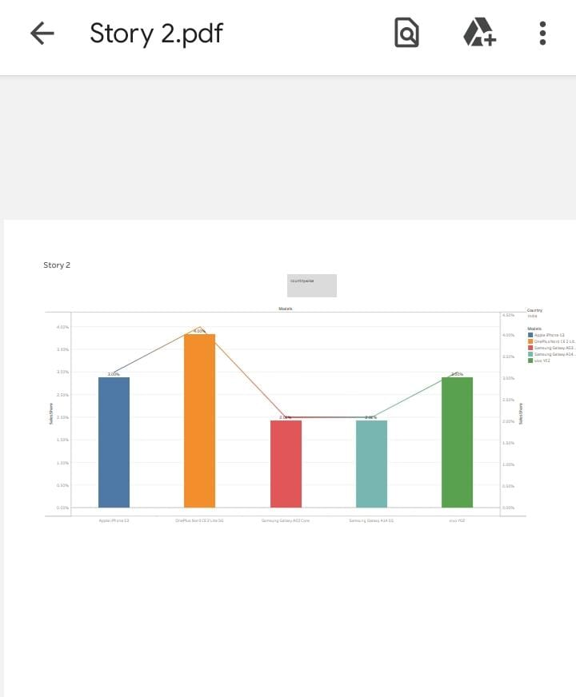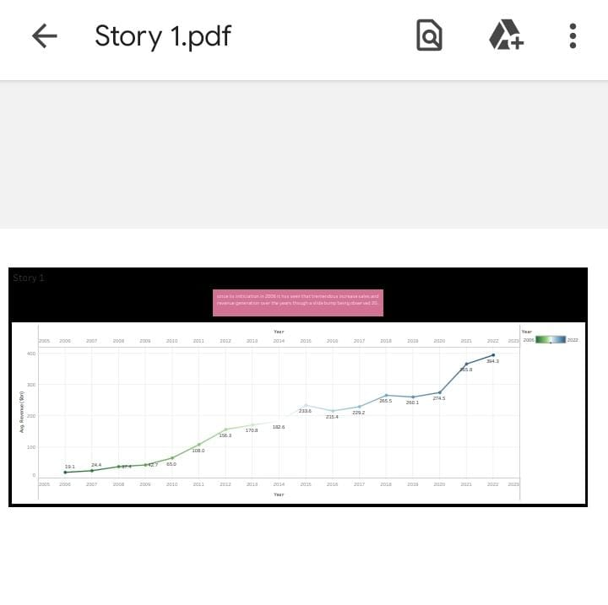

**4 ADVANTAGES & DISADVANTAGES**

4.1: Advantages

* We have got more knowledge about the features and various desktops those are so beneficial for us.
* It helps to get information which is useful for the future data analyst jobs.
* It improves our self-confidence and gets to know about the various models and specification about the apple iPhone.

4.2: Disadvantages:

* One of the disadvantages of the iPhone is that it has limited customization options. Unlike Android devices, users cannot customize their phone's interface, which can be a disadvantage for some people.
* iPhones are renowned for having high sticker prices. They frequently cost more than many Android phones with comparable or superior hardware specifications.
* Among these weaknesses are its highly-priced products, entering areas of higher competition, and incompatibility with other software.

**5 APPLICATIONS:**

* There are millions of great iPhone apps for students on the App Store right now that are excellent tools to help students with their studies.
* Information security. Information security companies unanimously agree that Apple devices are more secure than Android devices.
* You can use the Reminders app to make to-do lists for projects around the house and grocery lists that sort items into categories. You can also get a reminder about something when you arrive at a certain location.

**6 Conclusion:**

* Apple Inc (Apple) designs, manufactures, and markets smartphones, tablets, personal computers, and wearable devices.
* Apple Inc have a median target of 200.00, with a high estimate of 240.00 and a low estimate of 125.00.
* Based on our forecasts, a long-term increase is expected, the "AAPL" stock price prognosis for 2028-09-29 is 227.184 USD. With a 5-year investment, the revenue is expected to be around +31.69%.

**7 Future scope:**

* iOS App Development must keep track of these technological changes to provide a seamless experience for users. IoT, Machine Learning, Artificial Intelligence, and Augmented Reality are just a few of the latest technologies on which they can improve their knowledge.
* Incremental improvements like higher quality cameras and giant displays.
* iOS from Apple has been one of the most popular contemporary operating systems. Unlike the other platforms in today’s mobility solutions realm, iOS development demands a specialized and focused strategy for developing a typical mobile application.